

SNAPYUMMY

Intelligent Cooking Assistant

User Guide

Intelligent Reasoning Systems

Practice Module

Semester One 2021/2022

**PREPARED BY:**

|  |  |
| --- | --- |
| Student Name | Student ID |
| Chen Ziqi | A0231425R |
| Li Peifeng | A0231447J |
| Mediana | A0231458E |
| Xu Xuanbo | A0231436M |

Contents

1 Objectives 3

2 Scopes 3

3 System Overview 3

4 Installation 4

4.1 Requirements 4

4.2 Yolo Setup and Configuration 4

4.3 Neo4J Setup and Configuration 4

4.3.1 Docker Installation Part 5

4.3.2 PC Installation Part 6

4.4 Telegram Setup and Configuration 11

4.4.1 Generate Telegram Token 11

4.5 Google Dialogflow Setup and Integration 12

4.5.1 Build a Dialogflow Agent 12

4.5.2 Generate Google Dialogflow API Key 13

4.6 Backend Server Setup and Configuration 14

5 User Guide 15

5.1 Use Case Overview 15

5.1.1 Cuisines List 15

5.1.2 Dietary List 16

5.2 Cooking 16

5.2.1 Select cooking mode 16

5.2.2 Type in the ingredients or upload an image 17

5.2.3 Modify input ingredient 17

5.2.4 Input your preference 17

5.2.5 Choosing your favourite dish! 18

5.2.6 Check details for a dish 20

5.3 Browsing 20

5.3.1 Random Dishes 21

5.3.2 Specific Dishes 22

# Objectives

The objective of this document is to provide an overview of SnapYummy application and the necessary information to use the application. The manual assumes that the reader has sufficient understanding on system implementation, machine learning, programming language (Python), knowledge reasoning and representation.

# Scopes

The high-level scope of the user guide will encompass THREE (3) sections:

1. System Overview
2. Installation and Configuration
3. User Manual (Use Case)

# System Overview

Figure 1 shows the system overview for SnapYummy. Following are the components used in SnapYummy.

1. Telegram – Chat Messaging Platform for interaction between SnapYummy and users
2. Yolov5 – Object detection to detect the ingredients uploaded by users
3. DialogFlow – Intent detection to detect users’ request and intention
4. Neo4J – Knowledge graph to search for the search the recipe according to users’ requirement

Figure 1 System Overview

# Installation

## Requirements

| **Description** | **Specification** |
| --- | --- |
| **Hardware** | CPU: Intel(R) Core(TM) i5-10210U CPU @ 1.60GHz or higher  GPU: *Optional  RAM: 8GB or bigger  Hard disk: 1GB or bigger |
| **OS / Software** | OS: Windows 10  Software: Python3.7, Docker (for Neo4j library & data) |
| **Packages** | We have included all packages needed in the requirements.txt, please use ‘pip install’ command to install them. |

## Yolo Setup and Configuration

Minor setup and configuration are required for YOLOv5. The official YOLOv5 codes and our self-trained weights are included in the project and integrated. The backend script (reqHandler.py) will automatically initialize the model when it is executed and call the model when object detection is needed.

## Neo4J Setup and Configuration

We recommend users to use docker-based installation when they have not configured "neo4j" on their PCs. The docker-based method would be more convenient, simply because installing a docker is easier than installing a "neo4j" from scratch (we have configured all the things in advanced, which means you do not have to import data and create a database). If users have already installed "neo4j" on their PCs, then they can directly refer to "PC Installation Part".

### Docker Installation Part

#### Docker Installation

| **No** | **Steps** |
| --- | --- |
| 1 | Go to [Docker](https://docs.docker.com/desktop/windows/install/)[1] official website to install a Windows version of Docker. For the backend. Use WSL-2. |
| 2 | By default, the docker will be installed on your C: drive. If you want to move the data to other drive (like D:), you can refer to this [Windows 10 How to change Docker’s Image Directory](https://www.jianshu.com/p/e79f4c938000)[2] |
| 3 | Open the 'cmd' consoler and type 'docker' to check whether you have successfully installed it. |

#### Download and load the Docker Image

We have shared the docker image in [GDrive](https://drive.google.com/drive/folders/14pni4MBB_xiyYXP45kJB1JNwOrKtDCa2?usp=sharing)[3] (snapyummy.tar)

Use **docker load < snapyummy.tar** to load the local images:

b12172aed5b1: Loading layer[===========================>] 141.8MB/141.8MB

Loaded image: snapyummy:final

#### Check whether the load is successful

Run **docker image ls**

REPOSITORY TAG IMAGE ID CREATED SIZE  
snapyummy final 0ce5b4f1fc9c 2 minutes ago 862MB

#### Download and unzip the Data Volume

Download the data volume from [GDrive](https://drive.google.com/drive/folders/14pni4MBB_xiyYXP45kJB1JNwOrKtDCa2?usp=sharing) (neo4j.zip), unzip the file into **/home** directory (you can create it on any directory, e.g D:/nus/home/neo4j)

#### Create Container

1. Create a docker container by

**docker run**

**-d --name snapyummy**

**-p 7474:7474**

**-p 7687:7687**

**-v D:/NUS/project/home/neo4j/data:/data**

**-v D:/NUS/project/home/neo4j/logs:/logs**

**-v D:/NUS/project/home/neo4j/conf:/var/lib/neo4j/conf**

**-v D:/NUS/project/home/neo4j/import:/var/lib/neo4j/import**

**--env NEO4J_AUTH=neo4j/password snapyummy:final**

Some explanations:

**-v** means the docker container will create a share folder and mount it to your local file directory. (e.g local directory **D:/NUS/project/home/neo4j/data** is linked to docker container directory **/data**)

You can simply copy the following command lines:

**docker run -d --name snapyummy -p 7474:7474 -p 7687:7687 -v D:/NUS/project/home/neo4j/data:/data -v D:/NUS/project/home/neo4j/logs:/logs -v D:/NUS/project/home/neo4j/conf:/var/lib/neo4j/conf -v D:/NUS/project/home/neo4j/import:/var/lib/neo4j/import --env NEO4J_AUTH=neo4j/password snapyummy:final**

1. Use **docker ps -a** to check whether you have created the container.

CONTAINER ID IMAGE COMMAND CREATED STATUS PORTS NAMES

977b09c76544 snapyummy:final "/sbin/tini -g -- /d…" 10 seconds ago Up 9 seconds 0.0.0.0:7474->7474/tcp, :::7474->7474/tcp, 7473/tcp, 0.0.0.0:7687->7687/tcp, :::7687->7687/tcp snapyummy

By default, the docker will automatically start after the docker run command, if not, try to use **docker start (container ID)**

1. If everything goes smoothly, you can go to **localhost:7474** to check, the database name is **snapyummy**; the username is **neo4j**; and the password is **password**

### PC Installation Part

#### Download Files

Please download the original csv files at [GDrive](https://drive.google.com/drive/folders/1bKofDDYTlp8p1yRtn5hioRihpPKf1Z_l) neo4j_import_csv[4]

#### Batch Import

• The neo4j-admin script is an official neo4j script that can import data in batches. It is stored in the bin folder of the neo4j installation directory (windows and linux).

• To use this script, some csv files need to be created to meet the import conditions (such as certain mandatory fields). Please refer to this URL: https://neo4j.com/docs/operations-manual/current/tutorial/neo4j-admin-import/

• Use this script to import millions of data with one command as following (Please remember to adjust the paths)

Windows

**neo4j-admin.bat import**

**--database=kg-test3**

**--nodes=F:\share_file\recipe_header.csv,F:\share_file\recipe.csv**

**--nodes=F:\share_file\ingredients.csv**

**--nodes=F:\share_file\meal_type.csv**

**--nodes=F:\share_file\main_ingredients.csv**

**--nodes=F:\share_file\cuisine_type.csv**

**--relationships=F:\share_file\ingredients_recipe_header.csv,F:\share_file\ingredients_recipe.csv**

**--relationships=F:\share_file\sub_main_ingre.csv**

**--relationships=F:\share_file\recipe_meal_type_header.csv,F:\share_file\recipe_meal_type.csv**

**--relationships=F:\share_file\recipe_cuisine_type_header.csv,F:\share_file\recipe_cuisine_type.csv**

**--multiline-fields=true**

**--skip-bad-relationships**

Linux

**neo4j-admin import**

**--database=kg-test3**

**--nodes=F:\share_file\recipe_header.csv,F:\share_file\recipe.csv**

**--nodes=F:\share_file\ingredients.csv**

**--nodes=F:\share_file\meal_type.csv**

**--nodes=F:\share_file\main_ingredients.csv**

**--nodes=F:\share_file\cuisine_type.csv**

**--relationships=F:\share_file\ingredients_recipe_header.csv,F:\share_file\ingredients_recipe.csv**

**--relationships=F:\share_file\sub_main_ingre.csv**

**--relationships=F:\share_file\recipe_meal_type_header.csv,F:\share_file\recipe_meal_type.csv**

**--relationships=F:\share_file\recipe_cuisine_type_header.csv,F:\share_file\recipe_cuisine_type.csv**

**--multiline-fields=true**

**--skip-bad-relationships**

#### Do the inferring

Please refer to the session 5.2.4 Knowledge discovery using rule-based reasoning in our report

##### Main Ingredient:

① run cql below

**MATCH(r:recipe)-[hi:Has_Ingredient]-(ing:ingredient)-[bmi:Belong_Main_Ingredient]->(mi:main_ingredient)**

**CREATE(r)-[hmi:Has_Main_Ingredient]->(mi)**

② run cql below (delete duplicate relationship)

**MATCH (a:recipe)-[r:Has_Main_Ingredient]->(b:main_ingredient)**

**WITH a, type(r) as type, collect(r) as rels, b**

**WHERE size(rels) > 1**

**UNWIND tail(rels) as rel**

**DELETE rel**

3.2 Vegan Part:

① run cql below

**MATCH (r:recipe) -[hi:Has_Ingredient]->(i:ingredient)**

**set i.vegan = True**

② run cql below and replace the name 'EGG' with names in this list [MILK ,FISH, SEAFOOD, SHRIMP, CHICKEN,BEEF,LAMB,PORK,DUCK，MEATBALL，CRABMEAT，SHELLS，HAM，SAUSAGE，BUTTER] and continously run the cql

**match (i:ingredient) -[bmi:Belong_Main_Ingredient] ->(mi:main_ingredient{Name:'EGG'})**

**where i.vegan = True**

**remove i.vegan**

**return count(1)**

③ build new relations

**MATCH (m:meal_type{Name:'vegan'})**

**with r,size((r)-[:Has_Ingredient]->(:ingredient{vegan:True})) as c1,size((r)- [:Has_Ingredient]->(:ingredient)) as c2,m**

**where c1=c2**

**merge (r)-[himt:Has_Inferred_Meal_Type]->(m)**

3.3 Halal Part:

**MATCH (r:recipe) -[hi:Has_Ingredient]->(i:ingredient)**

**MATCH (i:ingredient) -[bmi:Belong_Main_Ingredient]->(mi:main_ingredient{Name:'PORK'})**

**set r.halal = False**

**return count(r)**

## Telegram Setup and Configuration

### Generate Telegram Token

Telegram token or key is managed by *BotFather,* the token is required to connect between backend server and telegram*.* Below are the steps to obtain the telegram token.

| **No** | **Steps** |
| --- | --- |
| 1 | Go to your Telegram account, and type BotFather in the search bar. |
| 2 | Click command /newbot to create a new bot |
| 3 | Type a name and username for your bot. If the username is already taken, BotFather will prompt you to change to another available username |
| 4 | After successfully choose a username, BotFather will provide the Telegram token along with other information. |
| 5 | Save the token and input into the backend script (refer to 4.6) |
| 6 | In the BotFather chat window, you may also click /setcommands to change the list of commands |

## Google Dialogflow Setup and Integration

### Build a Dialogflow Agent

| **No** | **Steps** |
| --- | --- |
| 1 | Go to [Dialogflow](https://dialogflow.cloud.google.com/)[5] and click Create new agent in the left sidebar menu |
| 2 | Choose a name for your virtual agent, set the default language, and click on Create |
| 3 | Click Intents in the left sidebar menu. Input the name of the Intents and click Create Intent   |
| 4 | Input the name of the Intent, Contexts, Training Phrases, Action and Parameters and Responses according to the use case. You may refer to Project Report for more details and examples. |
| 5 | Alternatively, you may download the RecipeAgent (DialogFlow) from Github [SystemCode/DialogFlow/RecipeAgent](https://github.com/SCNUJackyChen/IRS-PM-2021-11-07-IS03FT-GRP8-SnapYummy/tree/main/SystemCode/DialogFlow/RecipeAgent) [6] |

### Generate Google Dialogflow API Key

For backend server to reach Google Dialogflow.

| **No** | **Steps** |
| --- | --- |
| 1 | Go to [Google Cloud Platform](https://console.cloud.google.com/)[7], click APIs & Services and then click Credentials in the left sidebar menu |
| 2 | In the Credentials page, click Create Credentials and choose Service Account. |
| 3 | Input the service account name and description. Service account ID will be auto populated. Then click Create and Continue. |
| 4 | Grant the service account access to project. Select a role for this service account, example Owner or Editor. Then click Done |
| 5 | Under Actions, click Manage keys to generate API key for the created service account. Choose key type JSON. |
| 6 | Save the JSON API key and input into backend server |

## Backend Server Setup and Configuration

To setup the backend server, you need:

1. Use ‘git clone’ command to download the project from the following URL:

<https://github.com/SCNUJackyChen/What2Cook>

1. Open ‘reqHandler.py’ in the root directory of the project with any IDE.
2. At line 15, set ‘**telegram_botTOKEN**’ to be the token you get in 4.4.1.
3. At line 14, set ‘**df_agentID**’ to be the name of the Dialog agent you created in 4.5.1. You can find its name in the setting page:

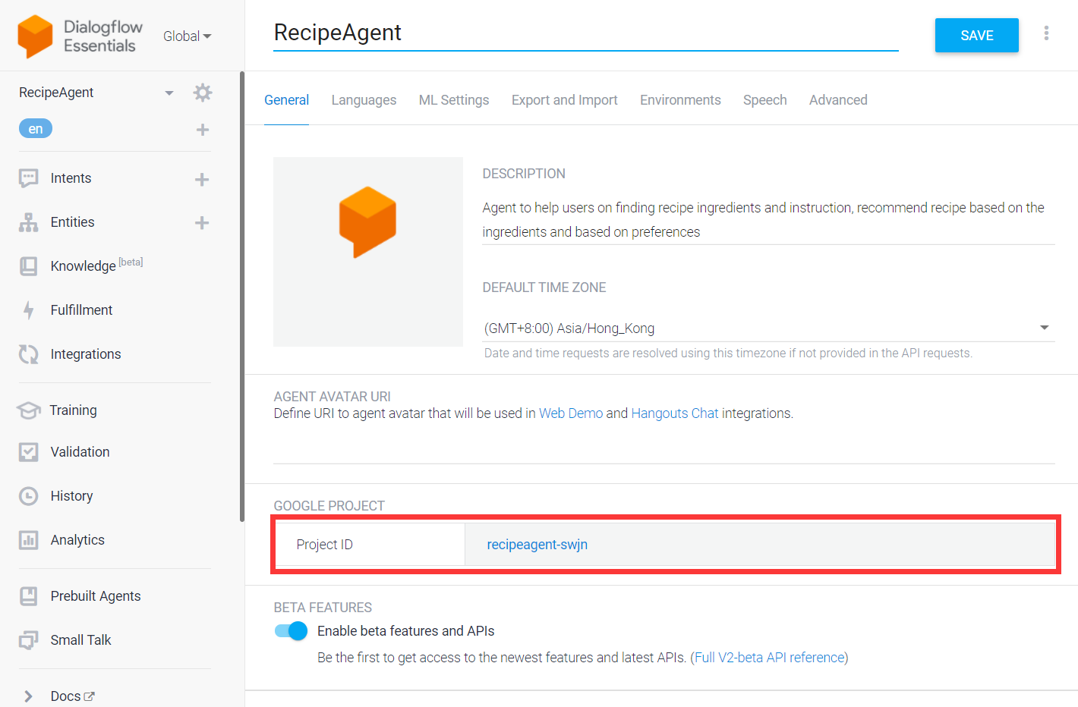

1. At line 16, set ‘**os.environ["GOOGLE_APPLICATION_CREDENTIALS"]**’ to be the absolute path of the JSON API key you saved in 4.5.2.
2. Run ‘reqHandler.py’, then you can now chat with the Telegram bot (ref to 5).

# User Guide

## Use Case Overview

SnapYummy provides 2 modes, cooking and browsing. In cooking mode, SnapYummy provides the recipe to cook according to users input, ie ingredients, cuisine preference and dietary preferences. For ingredients input, users may choose to input via image or via text. When users input image, SnapYummy will use its object detection mechanism powered by Yolov5 to detect the objects. This feature enables users to just snap a photo of their refrigerator easily and inform SnapYummy on the ingredients that users have. When users are unable to snap a photo, they may also just type-in their ingredients in text form.

The second mode that users may interact with SnapYummy is browsing mode. In this mode, users may browse recipe in two ways, leisure browsing and specific browsing. Leisure browsing is for users who do not have any idea on cooking and just like to browse on available recipe for getting ideas. While specific browsing is for users who are performing leisure browsing, but with specific cuisines and dietary preferences. This is useful for users who are going to host a party for family or friends with different preferences.

Following are the specific cuisines list and dietary list provided by SnapYummy.

### Cuisines List

|  |  |  |  |
| --- | --- | --- | --- |
| **Cuisine** | | | |
| Nigerian | Swedish | Australian | Filipino |
| Lebanese | Pennsylvania Dutch | South African | Turkish |
| Portuguese | Ethiopian | Greek | Tex Mex |
| Belgian | Cajun | Southern_Us | Swiss |
| Czech | Cajun_Creole | Caribbean | Austrian |
| Finnish | European | Italian | Dutch |
| South American | Hawaiian | French | Egyptian |
| Costa Rican | Canadian | German | Danish |
| Moroccan | Welsh | Vietnamese | Japanese |
| New Zealand | Georgian | Indonesian | British |
| Thai | Russian | Hungarian | Chinese |
| Asian | African | Indian | Pakistani |
| Irish | Malaysian | Norwegian | Iraqi |
| Puerto Rican | Creole | Korean | Jamaican |
| Native American | Mexican | Brazilian | Cuban |
| Palestinian | Spanish | Scottish | Christmas |

### Dietary List

Five entries are created for dietary entity including vegetarian, halal, eggetarian, fruitarian and non-vegetarians. Each entry is defined with synonyms that will map to reference values.

|  |  |
| --- | --- |
| **Dietary** | **Synonyms** |
| vegetarian | vegetarian, veggies, veg, vegan, vegetables only, veggies only, vegg, herbivorous, gluten-free, plant-eating, veggie-lovers |
| halal | halal, no pork, no lard |
| eggetarian | Eggetarian, vegetarian |
| fruitarian | fruitarian, fruits, fruit |
| non-vegetarians | non-vegetarians, non-veg, non-vegetarian, meat-lovers |

## Cooking

### Select cooking mode

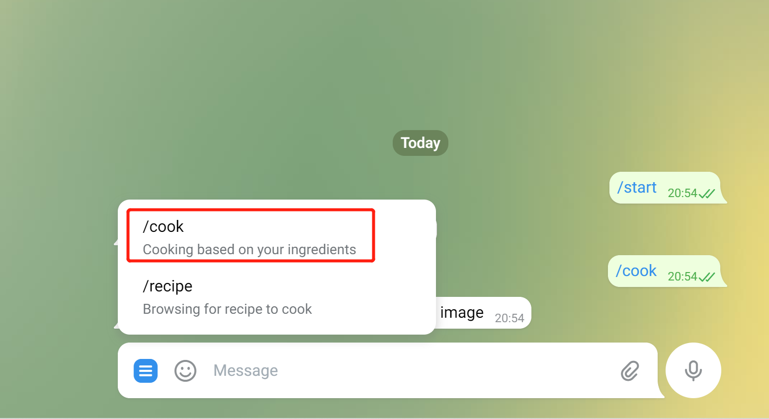

Figure 2 Cooking Mode

### Type in the ingredients or upload an image

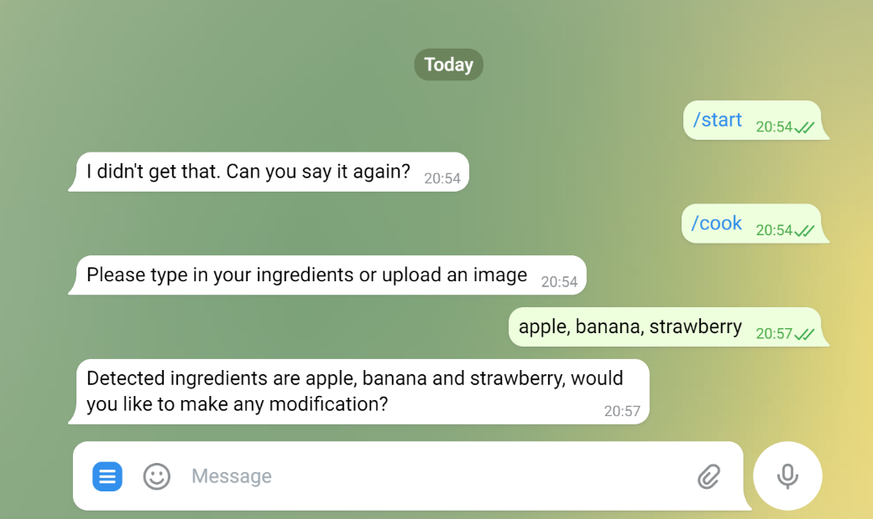

Figure 3 Type in Ingredients in Text Form

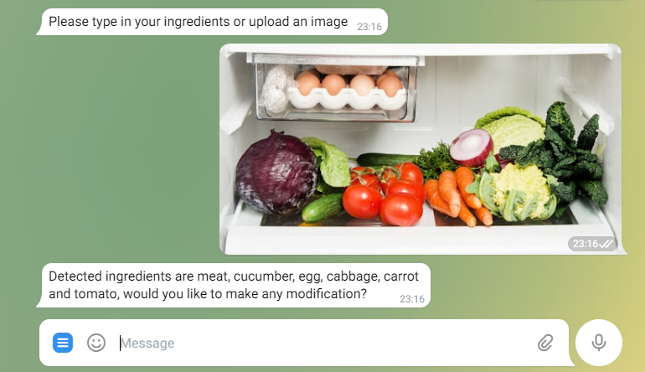

Figure 4 Upload Photo for Food Detection

### Modify input ingredient

If you are not satisfied with the detected results, you can choose to modify them. Just enter “yes” and input them.

### Input your preference

The robot will enquiry your dining preference for cuisine and dietary, if you do not have the preference, you can just tell it “No cuisine” or “No dietary”.

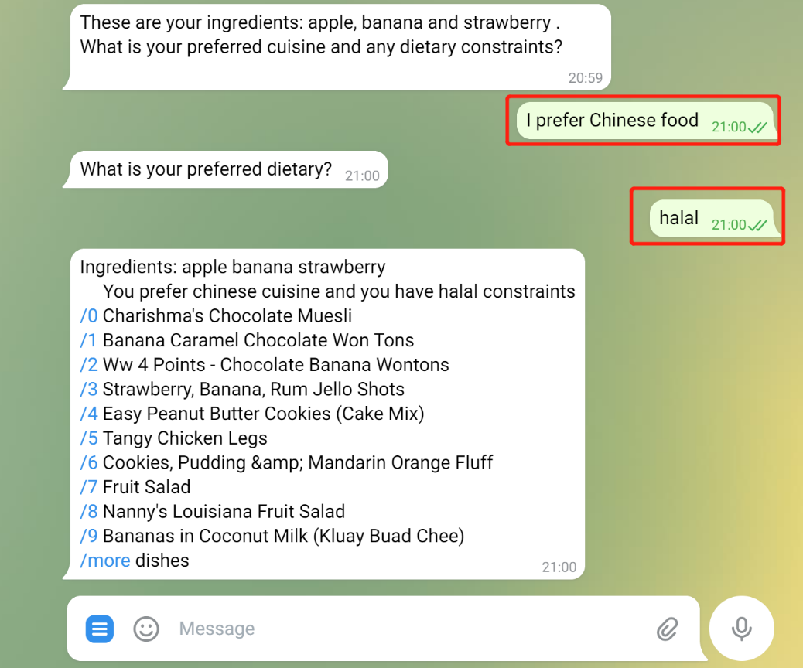

Figure 5 Input Preferences (Dietary and Cuisine)

### Choosing your favourite dish!

By default, the robot will recommend you 10 dishes based on your ingredients and preferences. You can click the number in blue highlight to see details or click “/more” to look at more dishes.

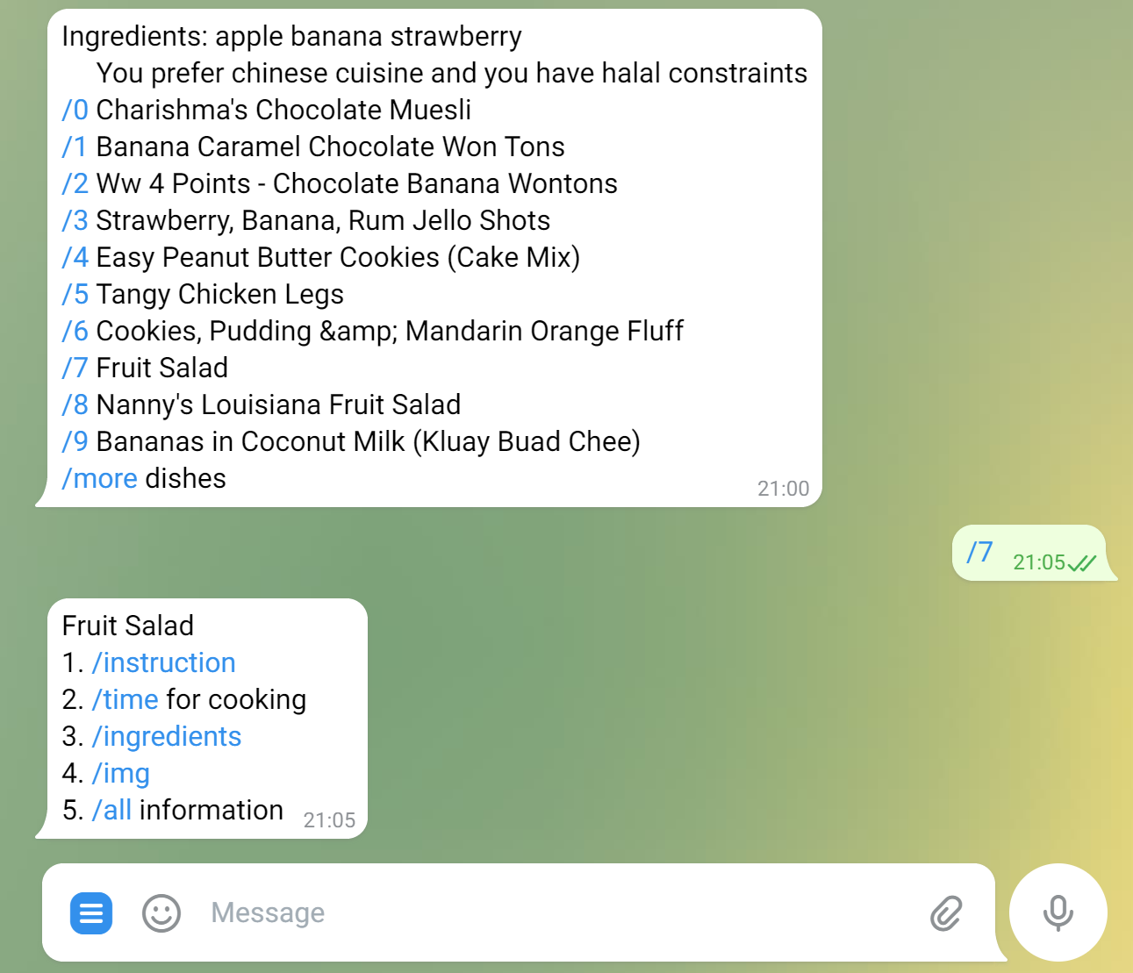

Figure 6 Selection of Recipe

### Check details for a dish

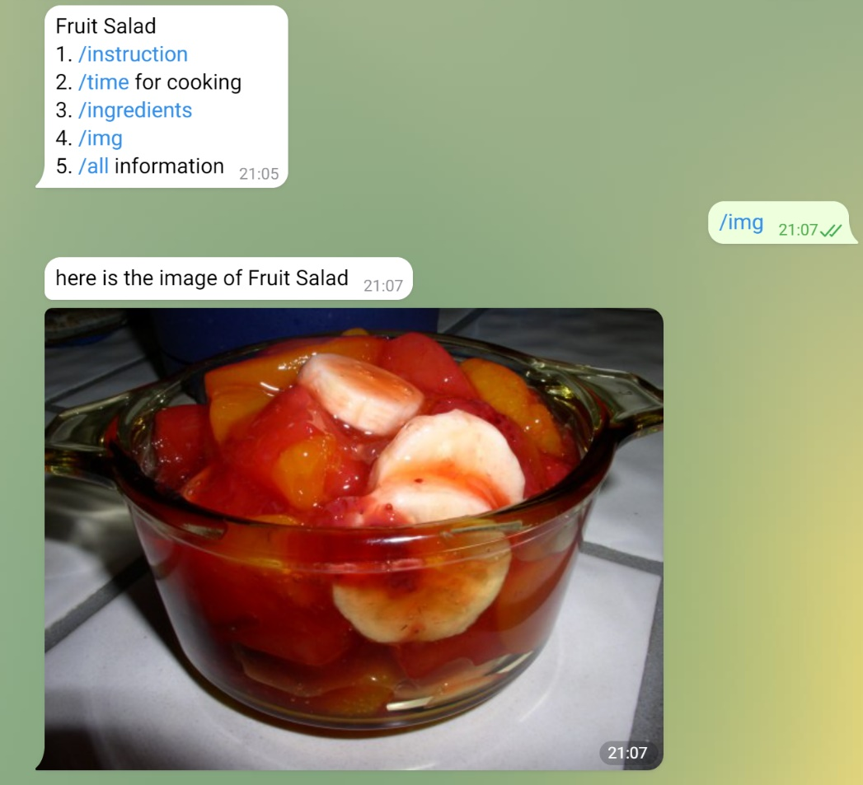

Figure 7 Details of Recipe

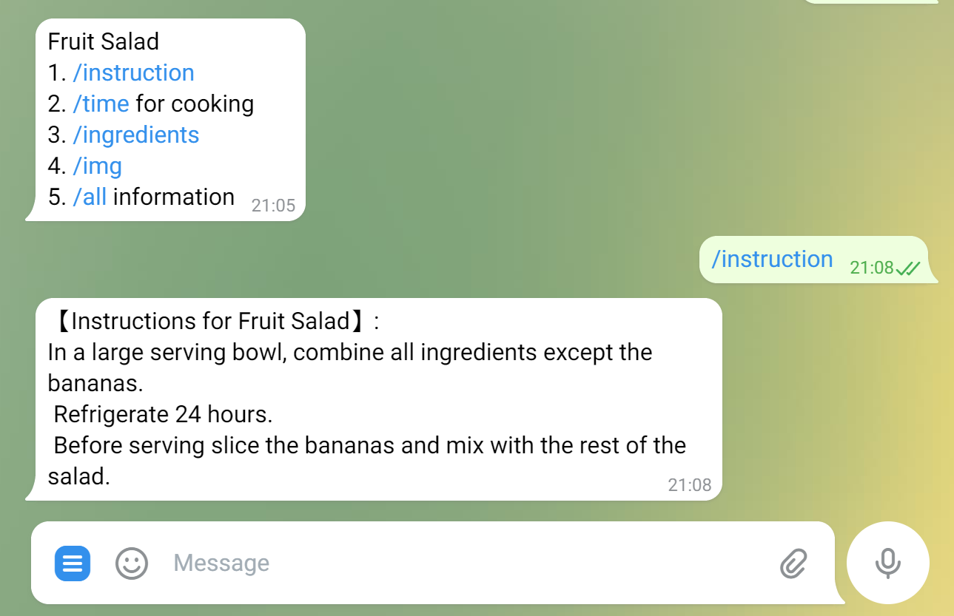

Figure 8 Recipe's Instructions

## Browsing

If you just want to have a look at our recipes or grab some new ideas for cooking, browsing mode may satisfy your demand.

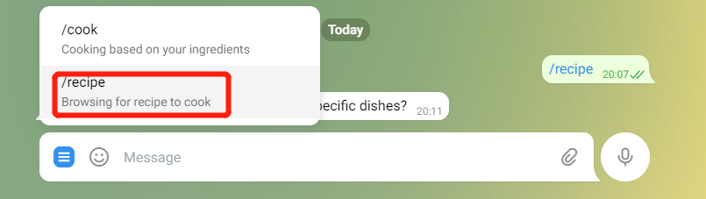

Figure 9 Browsing Mode

### Random Dishes

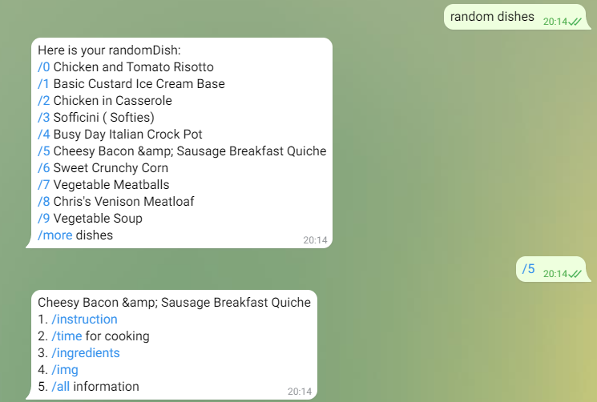

Figure 10 Random Recipe (Browsing Mode)

### Specific Dishes

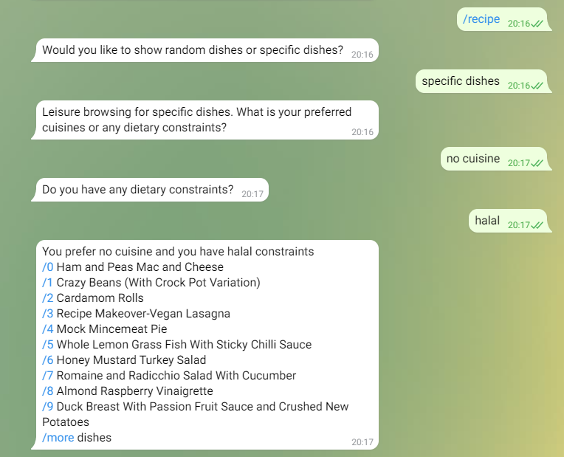

Figure 11 Specific Recipe (Browsing Mode)

|  |  |  |
| --- | --- | --- |
| **For ISS Use Only** | | |
| **Programme Name:** | **Project No:** | **Learner Batch:** |
| **Accepted/Rejected/KIV:** | | |
| **Learners Assigned:** | | |
| **Advisor Assigned:**  Contact: Mr. GU ZHAN / Lecturer & Consultant  Telephone No.: 65-6516 8021  Email: [zhan.gu@nus.edu.sg](mailto:zhan.gu@nus.edu.sg) | | |

1. Docker - https://docs.docker.com/desktop/windows/install/
2. Windows 10 How to change Docker’s Image Directory - https://www.jianshu.com/p/e79f4c938000
3. GDrive - <https://drive.google.com/drive/folders/14pni4MBB_xiyYXP45kJB1JNwOrKtDCa2?usp=sharing>
4. GDrive neo4j_import_csv - https://drive.google.com/drive/folders/1bKofDDYTlp8p1yRtn5hioRihpPKf1Z_l
5. DialogFlow - https://dialogflow.cloud.google.com/
6. Project Github - https://github.com/SCNUJackyChen/IRS-PM-2021-11-07-IS03FT-GRP8-SnapYummy
7. Google Cloud Platform - https://console.cloud.google.com/